**Automatic Digital Network MAP**

The Automatic Digital Network (AUTODIN) has supported the DoD's communications needs for thirty years. This main frame technology is manpower intensive and cannot be easily upgraded to support new information requirements. Its inability to provide the warfighter a wide range of information services, not just messaging, and its high cost of operations and maintenance requires the replacement of AUTODIN. The Defense Message Service [DMS] and the Defense Information Systems Network will replace AUTODIN and its messaging components. DoD plans to cease using AUTODIN by September 30, 2003.

The Automated Digital Network (AUTODIN) Automated Switching Center (ASC) provided the U. S. Navy, Army, Air Force, Coast Guard, other government agencies and industrial contractors with a worldwide, high-speed, automatic, electronic, data communications system. The ASCs are [were] responsible for the handling of communications data and other forms of digital data. The ASC maintains [maintained] 24 hour operation of major special purpose computers and their peripheral devices for on-line and off-line processing of communications data and other forms of digital data for AUTODIN.

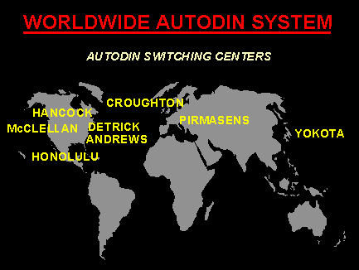

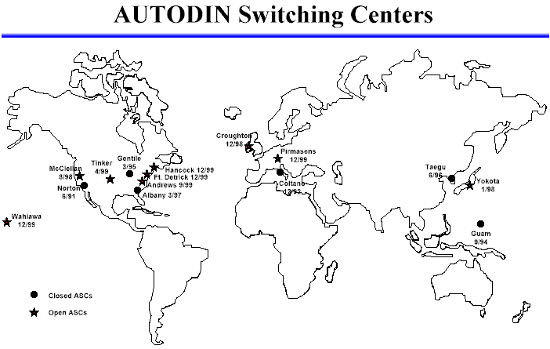

*not shown:* Udorn, Thailand and Clark Air Base, Philippines

**Sources and Resources**

* Information Technology Management: Transition From the Automatic Digital Network to the Defense Message System Department of Defense Inspector General report, April 8, 2003